Machine Learning-Based Earthquake Magnitude Prediction with SMS-Based Early Warning System

Abstract
Earthquakes are among the most destructive natural disasters, causing significant damage to human life, infrastructure, and the environment. Predicting earthquake magnitude using traditional statistical methods is challenging because seismic events are highly complex and nonlinear. This project proposes a Machine Learning-Based Earthquake Magnitude Prediction System that analyzes historical seismic data to estimate the magnitude of future earthquakes. The system uses earthquake parameters such as latitude, longitude, depth, time, and seismic measurements as input features. After preprocessing the dataset through data cleaning, normalization, and feature selection, machine learning algorithms such as Linear Regression, Random Forest Regressor, Decision Tree Regressor, XGBoost, and Artificial Neural Networks (ANN) are trained and evaluated. Model performance is measured using metrics including Mean Absolute Error (MAE), Mean Squared Error (MSE), Root Mean Squared Error (RMSE), and R² Score. The proposed system assists researchers and disaster management authorities by providing more accurate earthquake magnitude predictions, supporting early preparedness and risk mitigation strategies.

1. Introduction
Earthquakes are destructive natural disasters. This project uses machine learning to predict​ earthquake magnitude from historical seismic data.​

1.1 Background
Recent advances in machine learning enable the analysis of large seismic datasets and the identification of hidden patterns in earthquake activity.

1.2 Problem Statement
Traditional statistical methods struggle with complex and nonlinear seismic patterns. Accurate magnitude prediction can support preparedness and risk mitigation by SMS.​

1.3 Literature Survey
No. | Research Paper Title | Dataset Used
1 | Recent Advances in Early Earthquake Magnitude Estimation by Using Machine Learning Algorithms: A Systematic Review | K-NET, KiK-net, STEAD, IPOC and others
2 | A machine learning framework with parameter optimization and regional clustering for strong earthquake prediction | Japan and New Zealand earthquake catalogs
3 | Climatic and seismic data-driven deep learning model for earthquake magnitude prediction | Indonesia, Japan and HKKH-region earthquake datasets
4 | Scalable earthquake magnitude prediction using spatio-temporal data and model versioning | Spatio-temporal earthquake dataset
5 | Earthquake Prediction Using Machine Learning: Improved Magnitude Estimation with LSTM over Random Forest | Historical earthquake parameters: latitude, longitude, depth and magnitude
6 | Comparative Analysis of Decision Tree, Random Forest, SVM, and Neural Network Models for Predicting Earthquake Magnitude | USGS earthquake dataset
7 | Application of Machine Learning Models to Multi-Parameter Maximum Magnitude Prediction | Earthquake catalog from southern China’s North–South Seismic Belt
8 | Machine Learning Applications for Earthquake Magnitude Prediction in Western Turkey | Western Turkey earthquake dataset
9 | Deep learning model for predicting earthquake magnitude using bidirectional LSTM with attention mechanism on historical seismic data from 2017 to 2025 | 2,000 earthquake records from Mediterranean, Southern Europe, North Africa and Western Asia
10 | Forecasting earthquakes by Machine Learning techniques: lights and shadows | Southern California Earthquake Data Center (SCEDC) catalog

1.4 Research Objectives
No. | Identified Limitation / Research Gap | How Our Project Addresses It
1 | Many existing studies are region-specific, so their models may not generalize well to other geographical areas. | Use a larger and geographically diverse earthquake dataset to improve model generalization.
2 | Some studies depend on complex seismic waveform data, which may not be easily available. | Use commonly available features such as latitude, longitude, depth, time, and seismic measurements.
3 | Deep learning models such as LSTM and Bi-LSTM can require large datasets and high computational resources. | Compare traditional ML and advanced models and select the model that provides a good balance between accuracy and computational cost.
4 | Several studies focus on only one machine learning algorithm or a limited number of models. | Compare Linear Regression, Decision Tree, Random Forest, XGBoost, and ANN.
5 | Prediction performance differs depending on the quality and preprocessing of earthquake data. | Perform data cleaning, missing-value handling, feature selection, and normalization before model training.
6 | Some research emphasizes prediction accuracy but provides limited practical disaster-management support. | Add a risk-level and alert mechanism based on the predicted earthquake magnitude.
7 | Model performance is not always evaluated using multiple metrics. | Evaluate models using MAE, MSE, RMSE, and R² Score for comprehensive comparison.
8 | Highly complex models can be difficult to interpret for users and researchers. | Compare interpretable models such as Decision Tree and Random Forest with advanced models and select the most suitable model.
9 | Existing models may not be directly suitable for a simple real-time prediction application. | Develop a user-friendly Earthquake Predictor that accepts seismic parameters and displays the predicted magnitude.
10 | Accurate prediction alone does not directly provide actionable information to users. | Convert predicted magnitude into risk categories and warnings to support preparedness and disaster management.

2. Related Work
Previous studies have used Random Forest, LSTM, CNN, Bi-LSTM, XGBoost, and hybrid approaches for earthquake prediction. Performance varies across datasets and regions.

3. Proposed Methodology

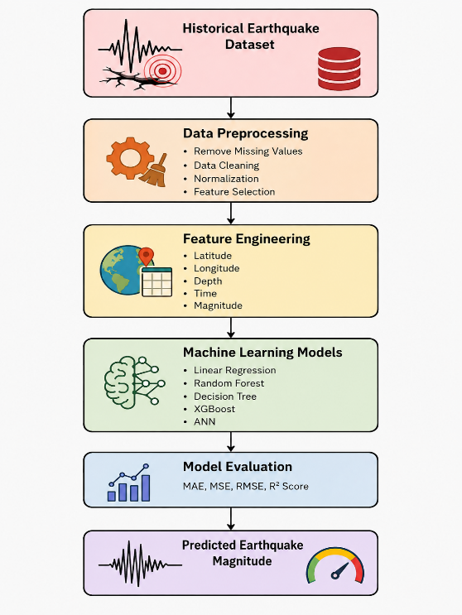
The framework includes data collection, preprocessing, feature selection, model training, evaluation, prediction, and SMS alert generation.

3.2 Dataset
- USGS Earthquake Catalog​

- Kaggle Earthquake Database​

- IRIS Seismic Data​

- NOAA Earthquake Database​

- Global Earthquake Model (GEM)​

3.3 Input Features
- Latitude: Location of earthquake occurrence.
- Longitude: Geographic position of the earthquake.
- Depth: Distance below Earth's surface where the earthquake starts.
- Time: Date and time information of seismic activity.
- Seismic Measurements: Recorded earthquake-related values.

3.6 Proposed Models
- Linear Regression:
Finds a simple relationship between input features and magnitude.
- Decision Tree Regressor:
Uses decision rules to make predictions.
- Random Forest Regressor:
Combines multiple decision trees for better accuracy.
- XGBoost:
A powerful boosting algorithm that improves prediction performance.
- Artificial Neural Network (ANN):
Learns complex patterns similar to the human brain.

4. Experimental Setup
- Python – Core development language
- TensorFlow / Scikit-learn – Earthquake prediction and analysis
- Pandas & NumPy – Data preprocessing and analytics
- IoT Seismic Sensors – Real-time earthquake detection
- GPS/GIS – Location tracking and affected-area mapping
- Twilio SMS API – Instant warning message delivery
- MySQL/Firebase – Data storage and user management
- Streamlit – Monitoring dashboard
- Google Colab – Model development and testing
- AWS/GCP Cloud – Real-time processing and scalability

4.5 Evaluation Metrics
MAE, MSE, RMSE, and R² Score are used to measure prediction performance.

5. Results
- Develop a model capable of predicting earthquake magnitude accurately.
- Identify the best-performing machine learning algorithm.
- Help researchers understand earthquake patterns.
- Support disaster management authorities in planning and preparedness.

6. Discussion
The study demonstrates the effectiveness of machine learning in predicting earthquake magnitudes and supporting disaster preparedness.

7. Limitations
Prediction accuracy depends on data quality, regional characteristics, and availability of historical seismic records.

8. Conclusion and Future Work
Machine learning can improve earthquake magnitude prediction and disaster response. Future work includes real-time IoT integration and advanced deep learning models.

References
References should include at least 30 research papers from journals and conferences related to earthquake prediction and machine learning.

